**Differentiability and continuity**

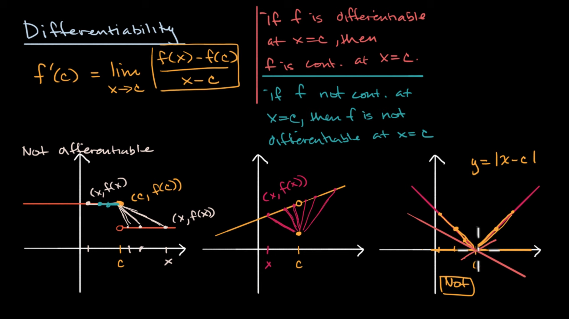

**Differentiability at a point: graphical**

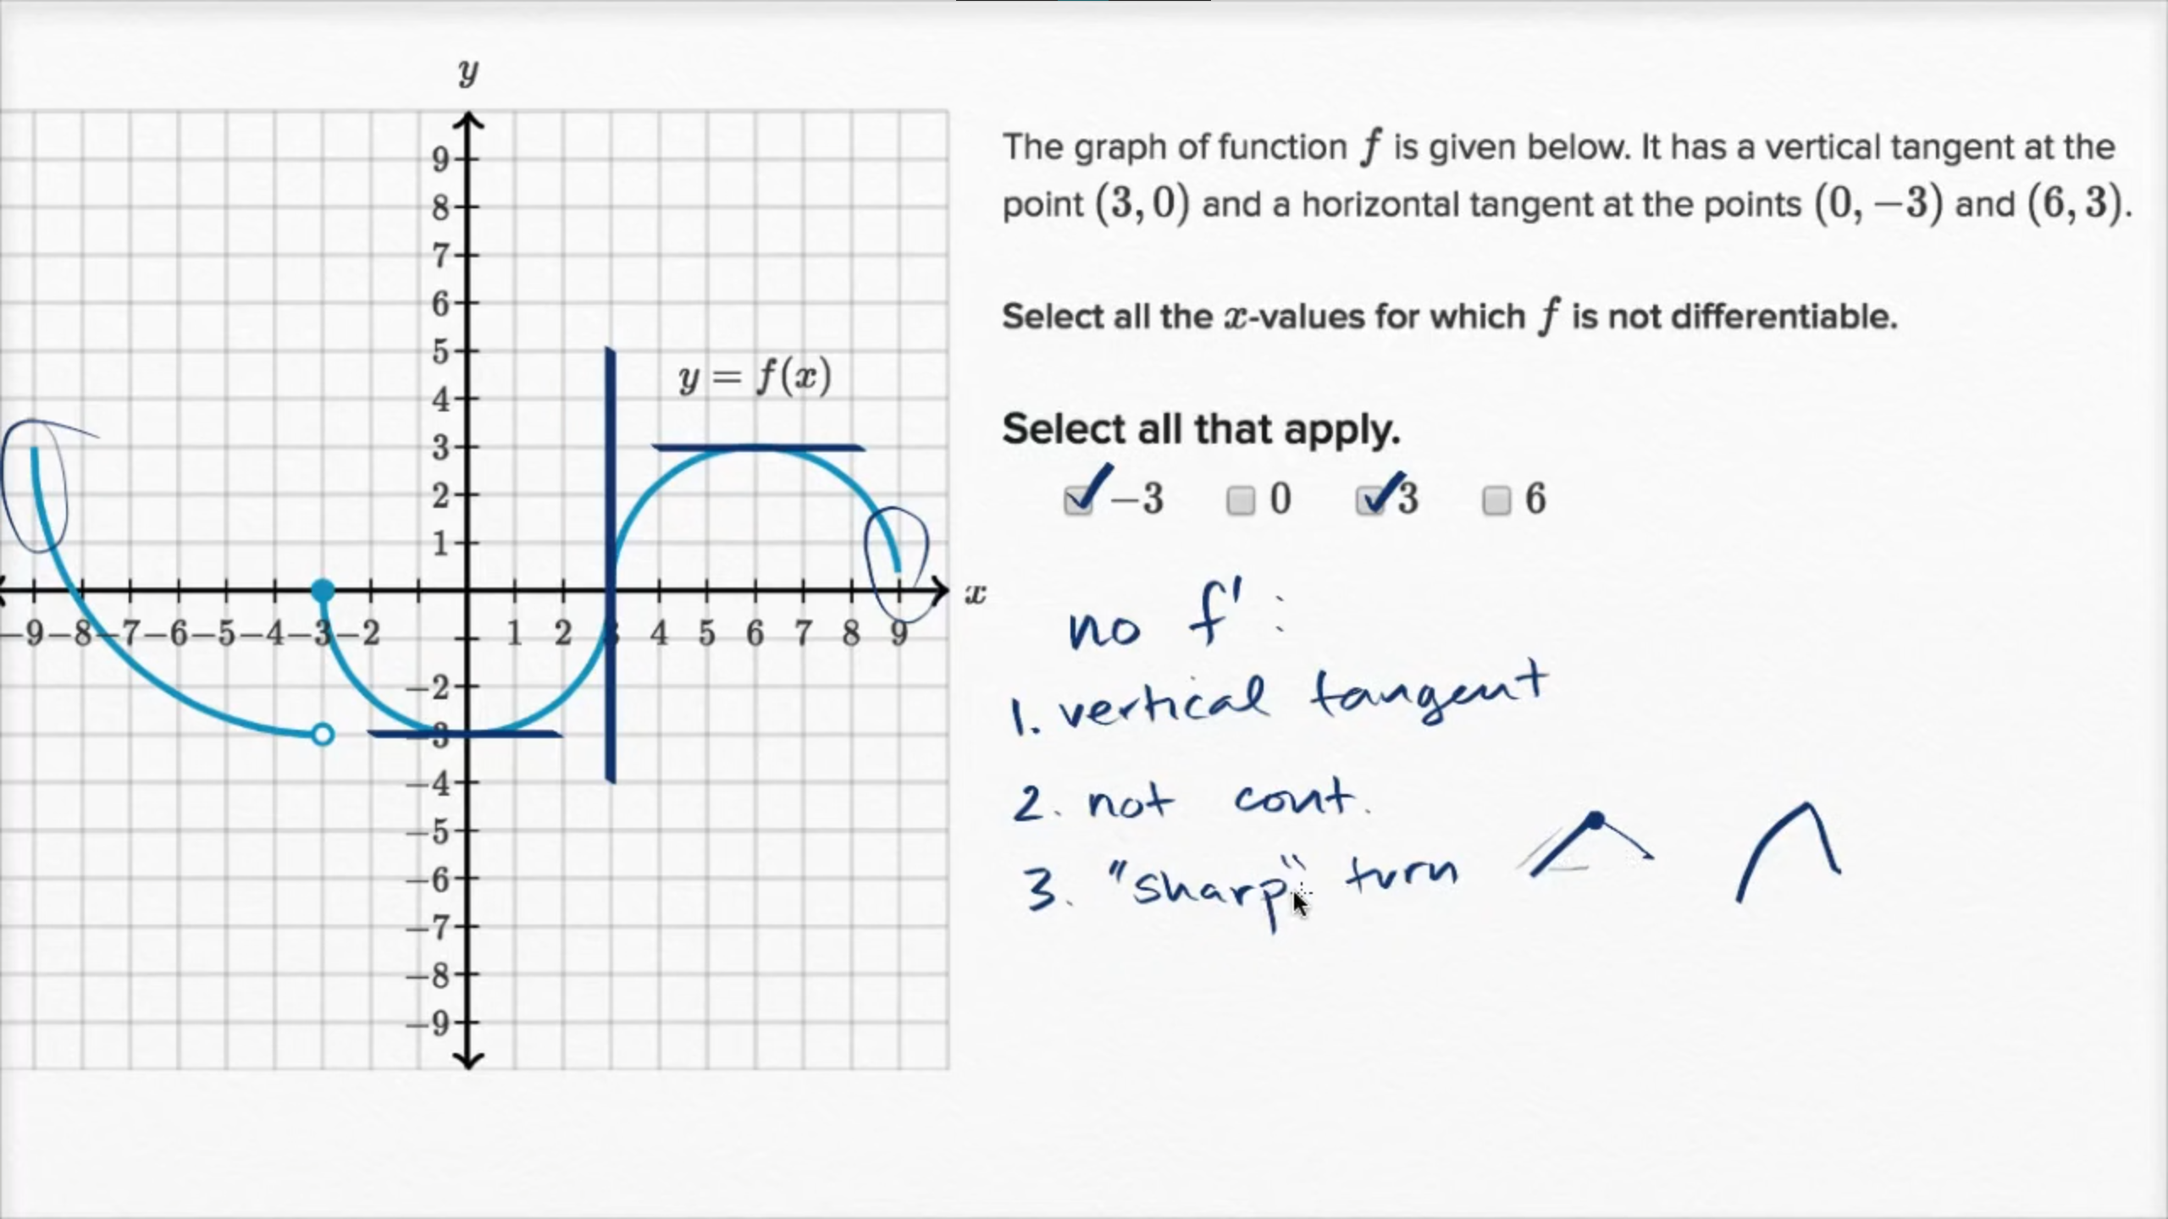

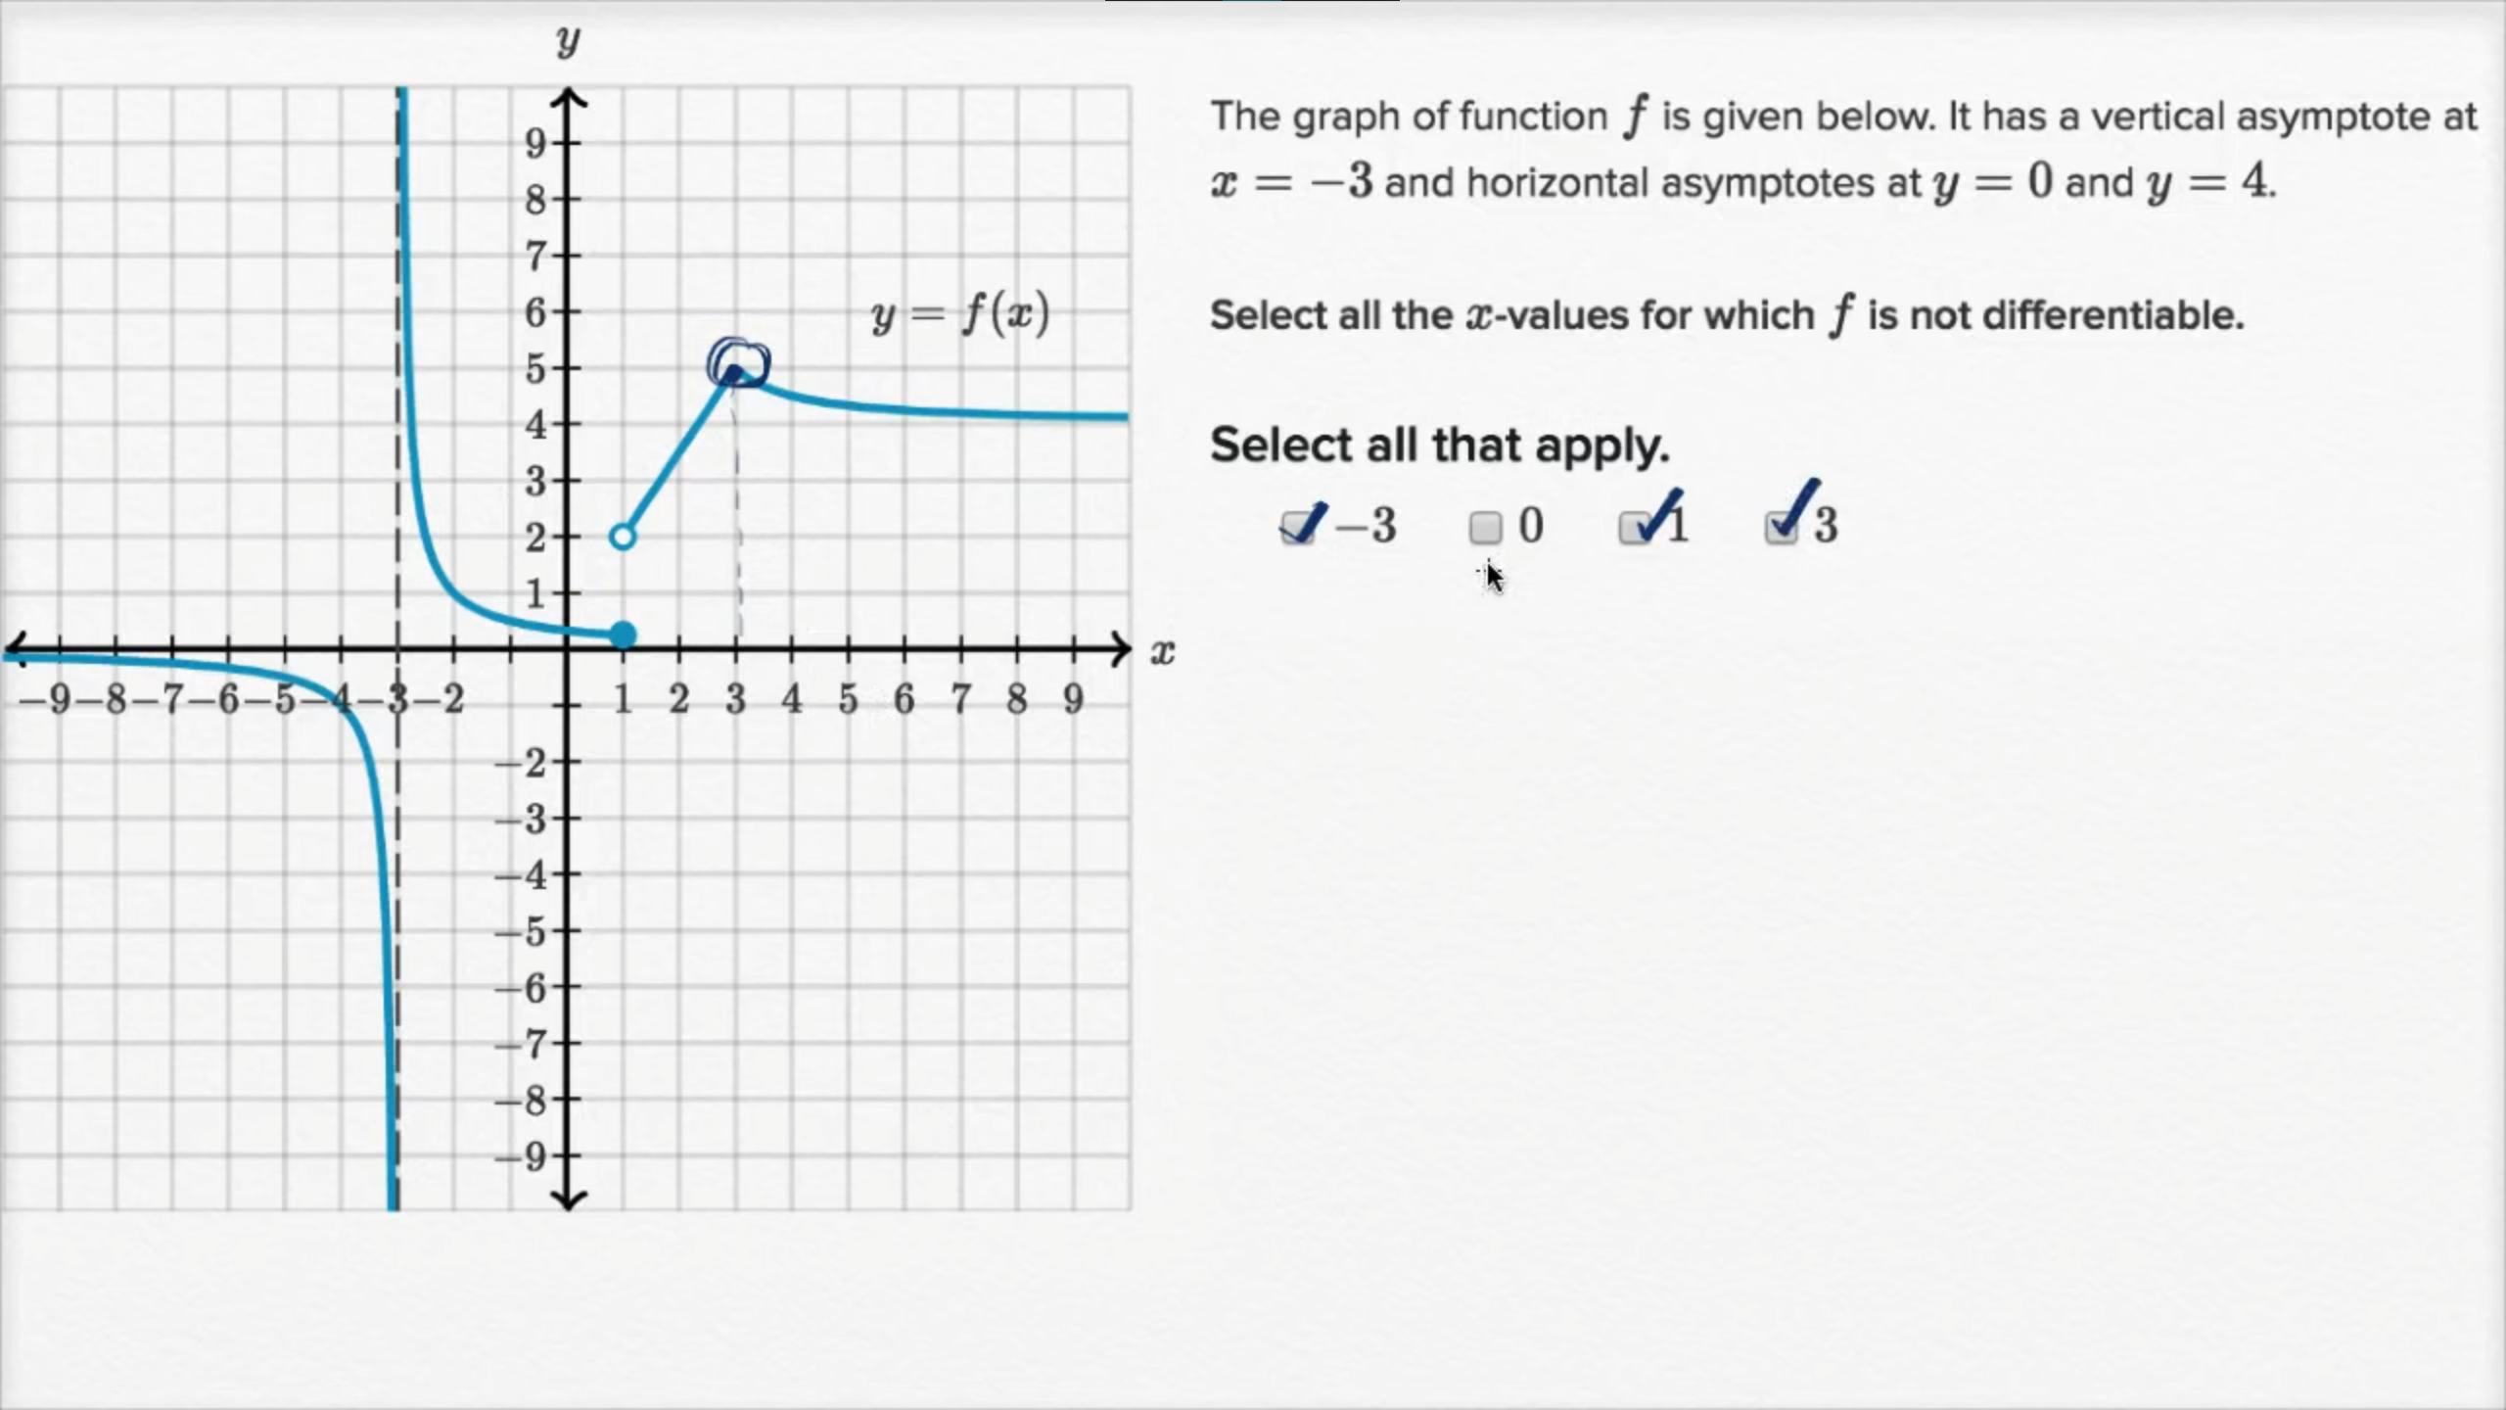

**Differentiability at a point: algebraic (function is differentiable)**

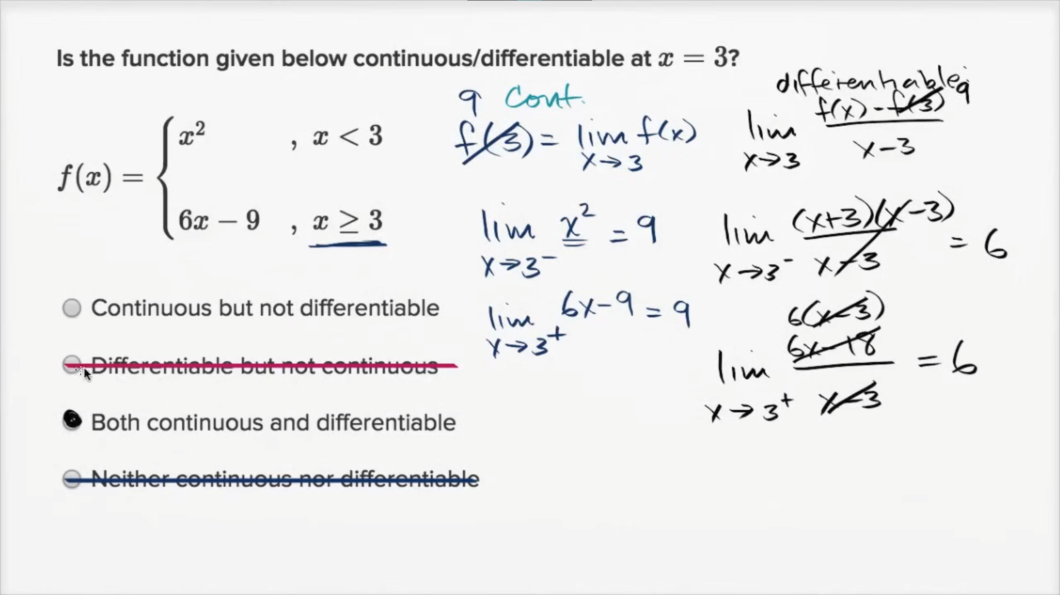

**Differentiability at a point: algebraic (function isn't differentiable)**

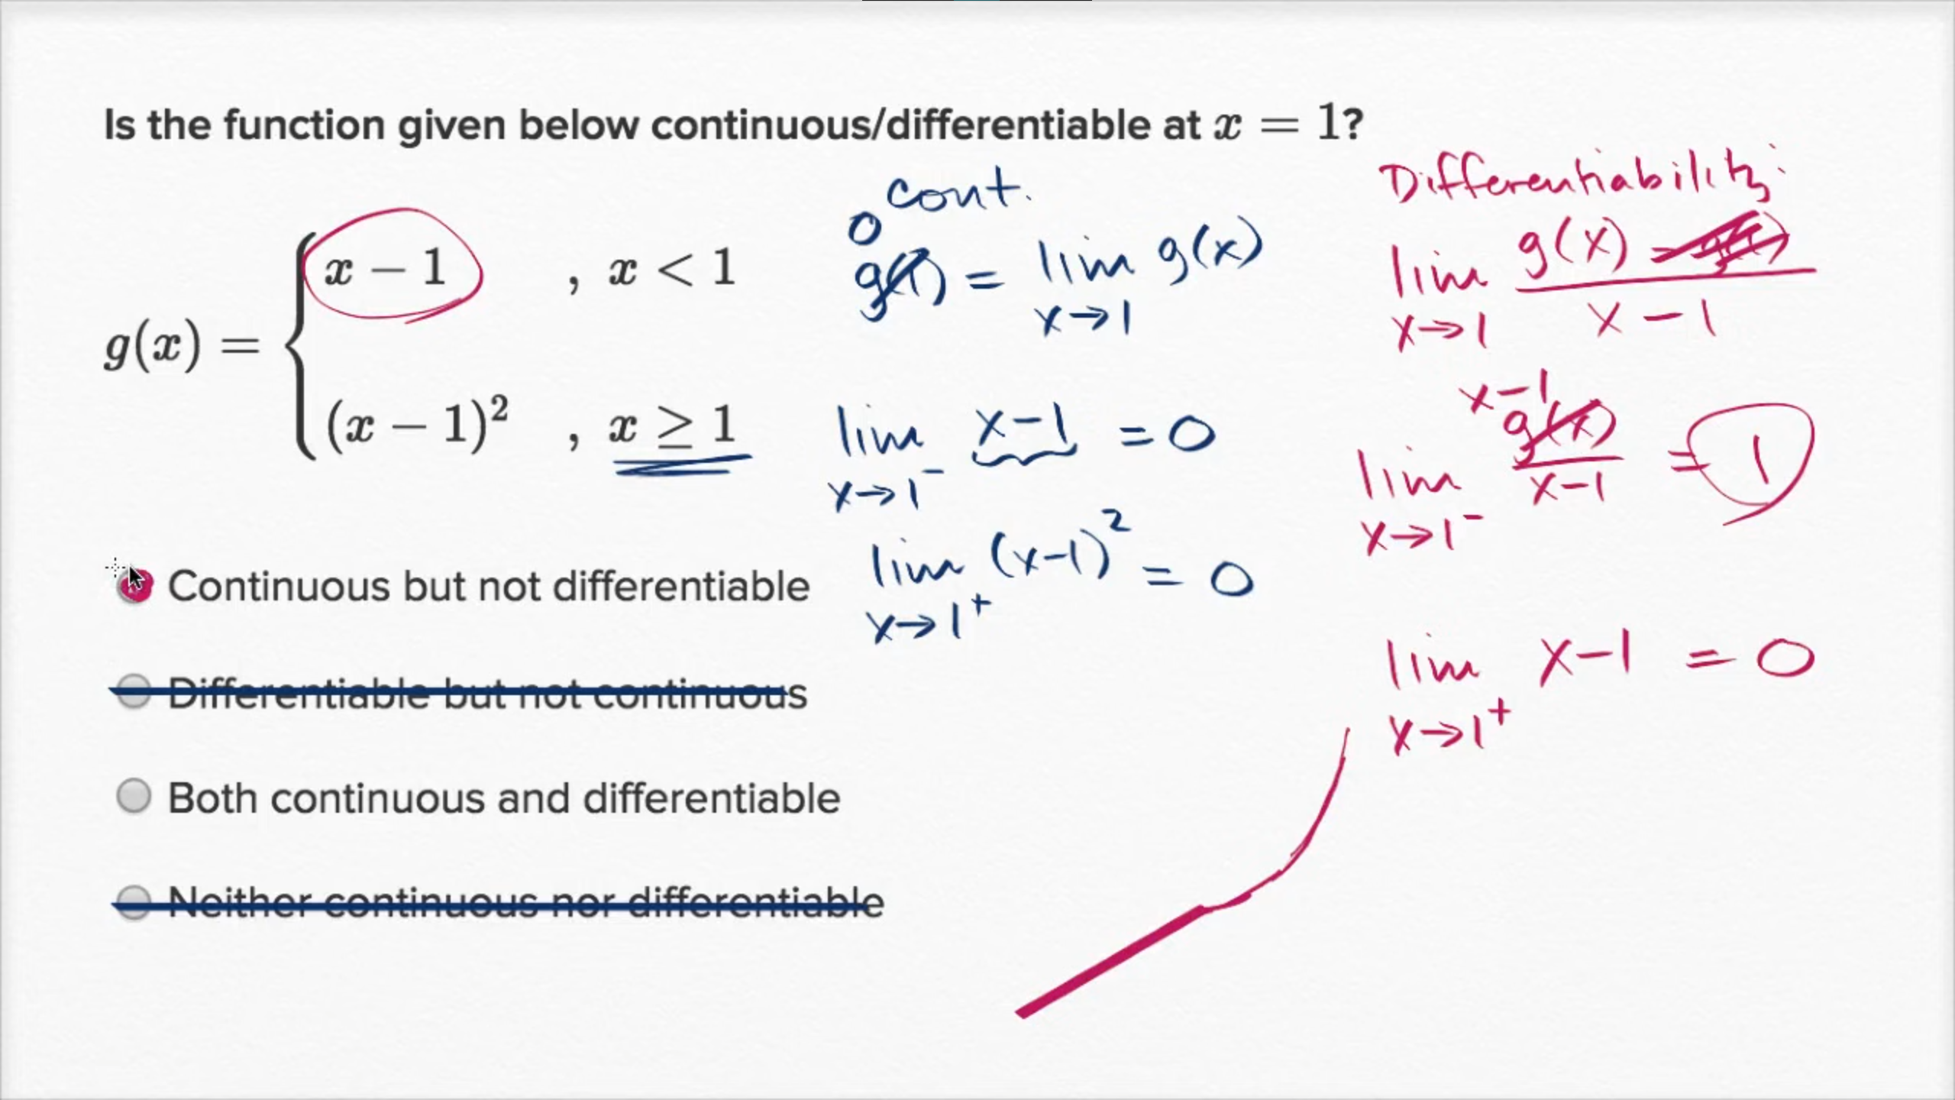

**Proof: Differentiability implies continuity**

